**Authors**: Manavalan, Nivedhan; Rao, Srivatsa; Shrivastava, Nikhil; Sinha, Ritwik, Sridhar, Arjun

**Disruptive Change**

Hospital Industry

Moving towards a different future

Disruption is inevitable in the $993 billion hospital Industry. With technology changing the business landscape and no market leader to leverage economies of scale, it is imperative that hospitals adopt to the changing times.

Contents

Introduction 1-4

References 1-8

Ch 1. Market Insight and Segmentation – Author: Ritwik Sinha 1-10

Introduction 1-11

Customer data 1-13

Front of the funnel strategy 1-15

The Adobe Marketing Cloud 1-17

References 1-19

Ch 2. Telemedicine Technology – Author: Nivedhan Manavalan 2-20

Introduction 2-21

Telemedicine Modalities 2-22

Demand Drivers and Stakeholder motivators 2-24

Trends 2-25

Implications for Hospital Industry 2-27

References 2-29

Ch 3. Mobile Healthcare Technology – Author: Arjun Sridhar 3-30

Introduction 3-31

Nature of suggested healthcare-related mobile application: 3-31

Useful performance: 3-32

Cost and time analysis 3-35

Implementation Challenge 3-37

References 3-39

Ch 4. Big Data Analytics and Decision Support – Author: Srivatsa Rao 4-40

Introduction 4-41

Value based Care 4-41

Clinical Decision Support (CDS) 4-42

What constitutes healthcare data? 4-43

Big Data trends in Healthcare 4-44

How can this be achieved: Big Data architecture? 4-46

Proposed architecture 4-49

References: 4-50

Ch 5. Security – Author: Nikhil Shrivastava 5-51

Introduction 5-52

Confidentiality, Integrity, and Availability (CIA): Why are they important? 5-53

Legal Requirements and Implications 5-54

Information Security in Hospitals 5-54

Healthcare security threats and mitigation 5-55

Implementation Plan 5-57

Cost Analysis 5-59

Appendix 5-59

References 5-61

Conclusion 62

The Need for Change: Cost Benefit Analysis 62

A peep into the future: implementation timeline 66

Improve healthcare outcomes 67

References 68

**Authors**

Rao, Srivatsa

[srivats.rao88@tamu.edu](mailto:srivats.rao88@tamu.edu)



Sinha, Ritwik

[ritwik.sinha@tamu.edu](mailto:ritwik.sinha@tamu.edu)

Manavalan, Nivedhan

[nivedhan@tamu.edu](mailto:nivedhan@tamu.edu)





Shrivastava, Nikhil

[nikhil.shrivastava@tamu.edu](mailto:nikhil.shrivastava@tamu.edu)

[nivedhan@tamu.edu](mailto:nivedhan@tamu.edu)



Sridhar, Arjun

[arjun@tamu.edu](mailto:arjun@tamu.edu)

[nivedhan@tamu.edu](mailto:nivedhan@tamu.edu)

Introduction

The healthcare industry is a combination of organizations and independent units in the society that provide services, care, and medical supplies to diagnose and treat patients. The industry encompasses several units including surgical and general medical hospitals, medical device manufacturers, pharmacies, drug manufacturers, independent medical practitioners, analytical instrument manufacturers, laboratory instrument manufacturers. The primary activities in this industry are pertaining to the services provided by the hospitals. These are categorized as - general hospital service, dental practices, and other special human health activities. The field of psychiatry and other specialty services are excluded when we discuss this industry. Per the World Health Organization, there are around 9 million physicians, 19 million nurses, 2 million dentistry personnel, 2.5 million pharmaceutical personnel, and over 1.5 million community health workers worldwide [1]. This stat makes it clear that the healthcare industry is one of the largest segments of the workforce in the world.  No one organization could be designated as the most important player in the industry, since, as we just saw, the healthcare industry is a combination of diverse entities.

The number of jobs provided by this industry in the United States is around 13.5 million [2]. In comparison with the other industries of the world, the healthcare industry is expected to surge in terms of the number of career opportunities provided. There are a variety of reasons why this is expected to be the case. Thanks to the advancement in medical sciences, the average lifespan of individuals are prolonged, thus requiring more health care treatment over the prolonged period. People in their 60s in the past would have needed 10-20 years of medical assistance. In today’s times, this number has risen. Yet another important reason for the growth potential of this industry is that the ‘baby boomers’ (persons born between 1946 and 1964) who comprise one of the largest segments of the population are entering the age of retirement. This, automatically, will result in an increase in the number of clients to the healthcare industry and an eventual increase in revenue.

Although the revenue potential of this industry is significant, there is a rising concern with respect to the affordability of healthcare. Per a report, the health care spending is expected to triple between 2015 and 2020. This rise in price has been consistent historically.  Issues with the infrastructure are contributing towards making it difficult for the public health systems to sustain current extents of service and affordability. Health insurance premiums are not helping either, with the employees estimated to pay 5% more in health insurance premium next year [4].  Direct stakeholders like the health insurance providers and the hospitals are leaving no stones unturned to implement cost containment measures. Although steps such as integration of verticals, adoption of non-traditional and lower-cost means to provide care, innovative procurement models, standardization of clinical processes, shared service centers are helping them progress in this regard, they still have a long way to go.   If cost is one concern, the inability to provide proper health care facilities to a sizeable amount of the population due to the lack of resources is another significant problem that needs to be addressed by the healthcare industry. Per a report [5], there are 3 million medical professionals in a world with over 7 billion people. This is a significant people-to-doctor ratio. Although not as alarming, the number of people in the United States who are not able to visit a physician is still significant enough. Low funding for health care put together with certain other market drivers are also causes that negatively impact access to medical care. Lack of qualified physicians to diagnose and treat illness is another reason. There is a growing demand for healthcare professionals around the world. Healthcare industry should look for alternate means to compensate for the lack of quality professionals.

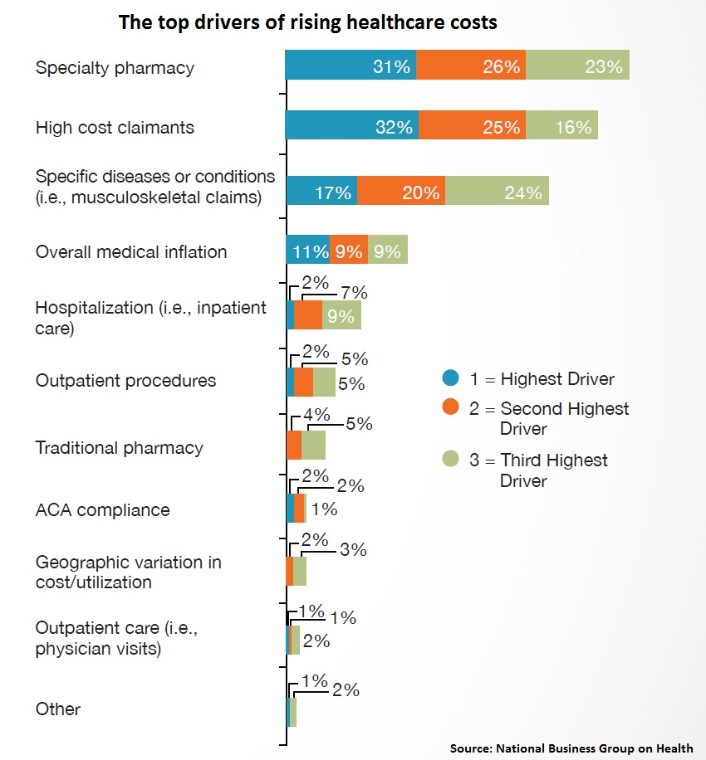The increase in the level of production proportionally affects cost saving in general. Economies of scale are not exactly as straightforward when it comes to the healthcare industry. Hospitals have tried them to increase their profitability by opting for mergers and strategic alliances. The logic behind this strategy is that as the size of the organization gets larger, the system will scale out, effecting a reduction in the operating costs despite delivering the same level of service and care. However, the numbers suggest otherwise and the impact of economies of scale have not been as pronounced in the healthcare sector [6]. A research on the same was conducted by *Strategy&* to see if the scale effects were seen in the larger organizations. Results show that for healthcare organizations with multiple facilities, there is no significant relationship between size and cost. The bigger size of the organizations has not guaranteed operating efficiencies. In addition, there is no relationship between quality and cost per encounter. The explanation for the above finding is that the health care organizations function as de facto holding units, i.e. a group of autonomous organizations, instead of one whole healthcare organization with standard procedures which would affect a cost reduction. If the organization functioned as one non-autonomous organization post the merger, standardizing their ways of operating in the administrative and clinical fronts, they can affect a cost reduction of around 15 to 30%. This is not as easy, since the healthcare organization need to make changes to their operating model, set appropriate decision rights, track their progress, and make way for separate dissimilar cultures in their mergers. Therefore, producing a cost cutting through mergers and alliances is not as simple in the healthcare industry and the organizations should look for alternate practical means to effect cost cutting and improve the operational efficiency.

Figure 1 Drivers of healthcare cost

The non-traditional means to provide health care by the usage of proven technologies from other industries are disrupting the healthcare industry. Innovation and the use of technology are the way forward for the industry. Healthcare mobile apps, telemedicine, implantable devices, are a few technology-enabled innovations that could help in providing better services when it comes clinical assistance at a reduced cost. The use of big data and healthcare analytics have the potential to complement the usage of the above-mentioned technologies when it comes to improving the quality of the service provided. Both public and private health units can adopt the technological assistance. They will need to reform their operating models to deliver an efficient and low-cost care without compromising on the quality. Safe and standardized service should be provided to individuals when and where needed with the assistance of technology. The potential impact of these technologies could act as a trendsetter when it comes how the established companies provide health care service.

One of the major considerations that the organization needs to take care of is the regulation of practices. The safety and the health of the patients should be of utmost importance. The organizations should ensure that these aspects are not compromised in the quest of incorporating technology into their operations. The privacy of the patients is another aspect that needs to be taken care of. Since many of the operations are going to happen over the internet, the patient information should be protected from cyber-theft and cyber-espionage. The organizations should be well equipped on both the legal and the technical fronts before the adoption of technology in their operations.

Considering the above insights, we propose a comprehensive strategy to leverage technology as an asset. The solution includes leveraging insights from market analytics to formulate a front of funnel (FoF) strategy, introducing telemedicine and healthcare technology and making data centers more efficient, secure, and more importantly a significant source of decision support. The resultant cost savings negates the needed investment within a reasonable timeframe and improves baseline in long term.

## References

1. WHO Statistical Information System, < <http://www.who.int/whosis/en/>
2. Anonymous, author at Wetfeet. “Industry Overview: Health Care” <<https://www.wetfeet.com/articles/industry-overview-health-care>>
3. George, Rebecca, OBE. Deloitte. “2017 global health care sector outlook”< https://www2.deloitte.com/global/en/pages/life-sciences-and-healthcare/articles/global-health-care-sector-outlook.html>
4. Mercado, Darla. “Expect your health insurance costs to rise in 2017”. < http://www.cnbc.com/2016/08/11/expect-your-health-insurance-costs-to-rise-in-2017.html >
5. Matchar, Emily. “Could This App Replace Your Doctor?” < http://www.smithsonianmag.com/innovation/could-app-replace-your-doctor-180958467/>
6. Kaul, Anil."Size should matter: Five ways to help healthcare systems realize the benefits of scale." <https://www.strategyand.pwc.com/reports/size-should-matter>

**Author:** Sinha, Ritwik

# Market Insight and Segmentation

Segment and Conquer!

Here we look at leveraging tools to understand and segment the market, to expand the user base and allow tailored strategies for each segment.



## Introduction

It is important to start by understanding the market that the corporation is in. Major healthcare providers have a successful track record of achieving financial results and may have been doing so for decades. However, research suggests that the percentage of firms that never put in the minimum amount of effort that is needed to quantify the market to be able to derive actionable insight, as well as the percentage of firms that are still relying on outdated research is alarmingly high. Without adequate market insight, the firm would essentially be flying blind. The next step would be to collate the generic information that has been collected and correlate this with the core competencies of the organization to identify which the subset of the healthcare market that is relevant to the firm. It is required to take special note of competitors in terms of what services they offer, and which services are difficult to compete with (and consequently identify a smaller section of the market subset that is feasible to pursue). This step is an essential prerequisite that positions the firm to successfully segment the market.

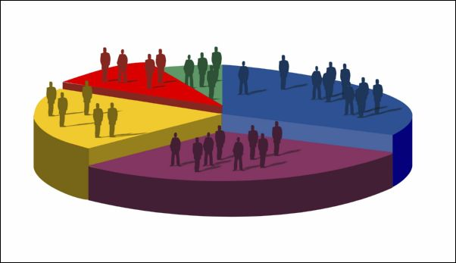After gaining market insight, it is time to move on to segmenting the market that the firm has deemed relevant to its business. Without segmentation, it would be impossible to devise a business strategy that focuses on each of these groups of users appropriately.

Figure 1‑1: Market Segmentation

Customers can be classified based on multiple dimensions as illustrated below-

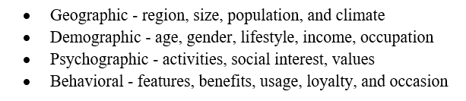 

Figure 1‑2: Market Segmentation Dimensions

The hospitality market needs to be segmented, with specific focus on-

* Segments must be **identifiable** so that they can be measured (not just initially, but also as needed). This would also enable better reporting and accurate tracking, which would then help in future decision making.
* Segments must be of a **substantial** size to be profitable and justify the resources required to work with them.
* Segments must be **durable** to maintain the stability of cost and profits, and ideally, be poised to naturally expand as time passes.
* Segments must be defined with highly limited ambiguity and ensured to be **accessible** by communications and distribution channels.

Optionally a persona may be defined for each of the market segments to better understand user behavior to better customize solutions. Different types of customers have different needs. At the same time, there are customers with similar needs. These commonalities arise since there is something common in the background that they come from. For instance, people in the same age group tend to suffer from (and hence are interested in the treatment of) similar kinds of health ailments. Alternatively, they might share a similar level of expertise in technology. The segments can be prioritized based on their attractiveness. Two of the most important factors to consider this attractiveness would be the cost to acquire customers along with the returns per customer (A lower cost and/or higher return makes the segment more attractive). During the process, the healthcare provider may come across some niche markets that are closely aligned with its product offerings, and work well with the core competencies. These segments should be given special heed by targeting exclusive solutions towards these segments. For instance, there is a group of medical personnel who want to work as advisors for multiple healthcare providers. They do not have any exclusive affiliations with hospitals and work by charging patients a consulting fee, part of which goes to the institution that brought them the patient (if any). Such a medical practitioner would be extremely if he is provided the ability to consult without having to physically travel. A virtualized interaction with the patient would not only allow faster access and increased availability, but this would also allow the practitioner to earn more by saving on travel time.

## Customer data

Customer data will need to come from somewhere to be able to more accurately segment the customer base. What we recommend is ‘Dun and Bradstreet’. Dun and Bradstreet, which has been in operation for almost 200 years. They have been amassing huge amounts of customer data from over 20000 data sources and are unparalleled in this field. Not only is the data extensive in terms of the number of customer records, it is also comprehensive, covering over 100 fields of usable information for the typical customer! The same service providers also have a competent analytics solution that can help with analyzing these huge datasets. However, we recommend going with an Adobe Marketing Cloud subscription, which is significantly more powerful.

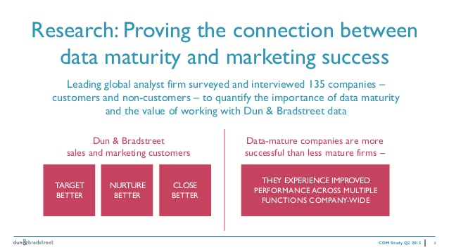

Figure 1‑3: Dun and Bradstreet Facts

Of course, creating growth depends on how insights and information are used identify and enhance the opportunities that might be hidden in relationships with existing customers and prospects. By identifying the most valuable relationships within data, one could potentially model behaviors and predict smarter outcomes that lead to better results. These decisions ultimately affect the long-term success of businesses. This data is not only going to be helpful when segmenting the market but will also go a long way in accurately simulating and executing large scale campaigns. When kept synced with the Dun and Bradstreet system, the data stays current. This means that any insight extracted from it will be as dependable as the model used to perform the calculation.

## Front of the funnel strategy

The front of the funnel is a powerful and time-tested approach when looking to expand the user base in any market. Various stages include exposure, discovery, consideration, conversion, customer relationship, and finally retention, as illustrated in the diagram below.

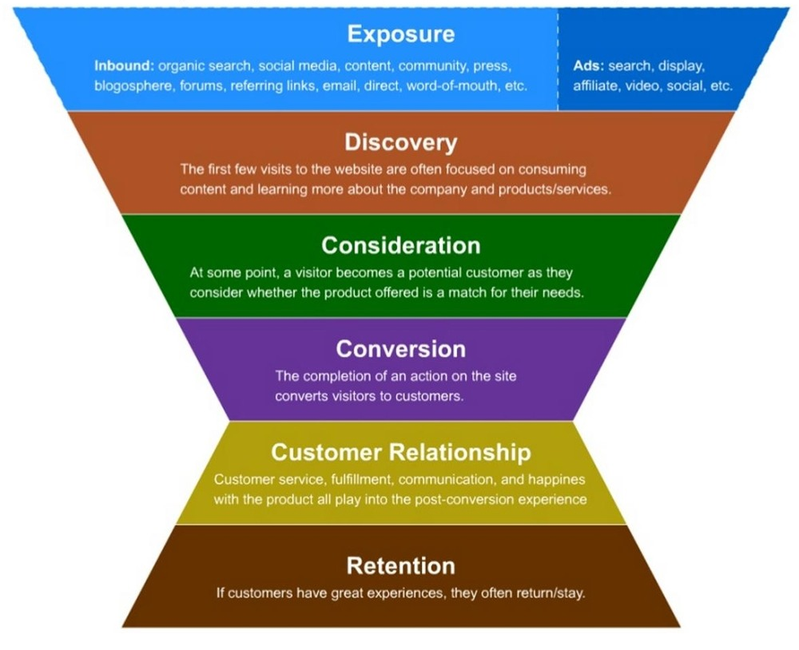

Figure 1‑4: Front of Funnel Strategy

The width of the funnel at any stage represents the approximate number of customers or potential customers involved at that stage. Note that the shape of the funnel keeps reducing from the exposure stage all the way till conversion, but then expands again from customer relationship through retention. This expansion in the final stages is known as the loyalty loop, where the customer continues to be involved in the same business because he likes the service provider. Additionally, given the reviews that he shares with the community, he can not only bring his own business to the service provider but also that of his friends and family.

To maximize the throughput of the entire process, i.e. to maximize the number of customers, the entity has 2 fundamental options:

1. increase the size of the mouth of the funnel
2. change the funnel gradient

While increasing the **size of the mouth of the funnel** can be achieved by improving marketing outreach, there are other newer and more innovative ways of achieving this. For instance, when we look at “Mobile Healthcare Technology”, which we will be looking at in greater detail in this report, there is scope to provide value to users at no cost to them. This could include health tracking applications, health advisory applications, etc. (with appropriate disclaimers) – all with the purpose of increasing visibility in the market and creating a new steady stream of users who can gradually be converted to loyal paying customers. It is then expected that with the size of the mouth of the funnel having been increased, the rest of the funnel will follow suit.

Change in **funnel gradient** is relatively more difficult to achieve as involves multiple processes and systems across the organization. For instance, the organization would need to invest in an interactive front end (a consumer website) that entices users and gains their confidence with its emotional appeal. This site would also need to be bootstrapped and mobile responsive to be able to cater to the needs of users using a variety of mobile devices. Multiple techniques can be employed to ensure that the users not just feel emotionally connected with the organization, but also see a clear logical flow in terms of what they are expected to do next to avail themselves of the service(s) that they came seeking.

Care also needs to be taken to ensure that the different market segments that had been identified earlier, are being treated appropriately. For instance, when a customer is in the consideration phase, he often needs some external help in terms of being shown how the firm’s service offering is an excellent match for his needs. At this time, all the investment that has been done to define a persona that best describes him will come in handy. There will also be an opportunity to cross-sell and upsell as appropriate, which is again aided by the customer study that has been performed using Adobe’s Marketing Cloud.

## The Adobe Marketing Cloud

One great tool to perform market segmentation is the Adobe Marketing Cloud’s Campaign. This seamlessly integrates with the remainder of the cloud offering.

 *“Adobe Campaign provides best-in-class campaign, offer, and personalization management capabilities for intuitive, touch-friendly marketing automation across all channels—digital and traditional. Adobe Campaign addresses a key challenge for marketers: how to build and extend relationships with their customer base to drive top-line revenue growth and ROI.”,* Adobe Systems Incorporated [1]

Using this tool, the entity would be able to achieve targeted segmentation, which is to say that it could be able to-

* Target specific audience groups in external campaigns with comprehensive list selections and an intuitive touch interface, which makes it especially easy for business users.
* Use information from the integrated customer profile such as consumer interests or channel preferences to define custom audience segments.
* Automate and adapt targeting strategies based on changing consumer preferences and behaviors that build and sustains customer lifetime value. [1]

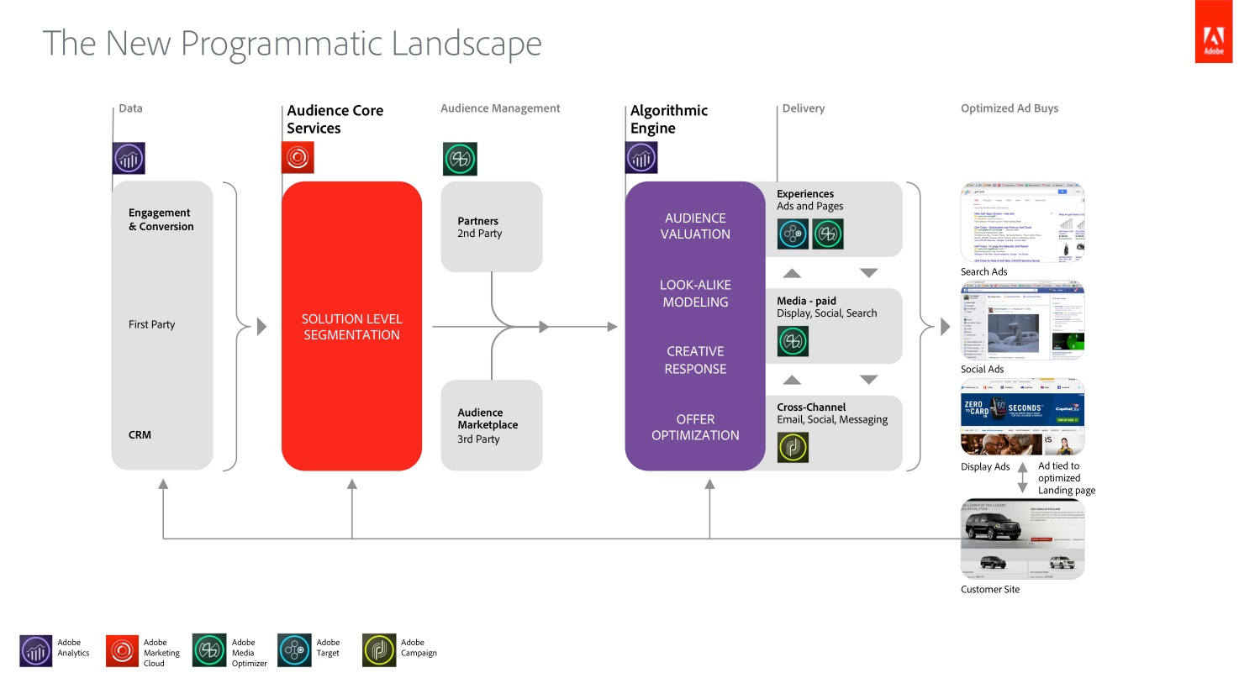

Figure 1‑5: Market Segmentation Process using Adobe’s Marketing Cloud Solution

A couple of years back, Adobe introduced a new algorithmic engine along with advances in Adobe Marketing Cloud Audience Core Services to combine the power of data-driven marketing and advertisement technology. This would help tie the complete the solution together, and prove to be an asset not just when using technology to segment markets, optimize and target healthcare solutions appropriately, but also when reaching out to the masses to educate them about the many benefits of this approach.

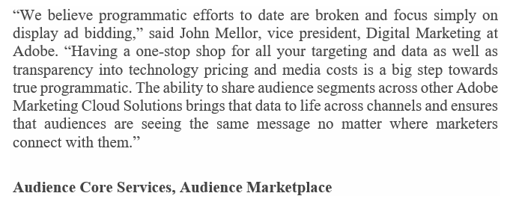

## References

1. Adobe Campaign Solution Overview. 14th April 2014 <http://wwwimages.adobe.com/content/dam/Adobe/en/solutions/campaign/pdfs/adobe-campaign-solution-overview-ue.pdf>

**Author: Manavalan, Nivedhan**

# Telemedicine Technology

Bringing the doctor to you

Telemedicine or Telehealth technology is a burgeoning industry with revenues of over $645 M annually. The industry is set to experience exponential growth in the next few years with revenues reaching $3.5 B by 2020. With low barriers to entry and high disruptive ability, the Hospital industry needs to be wary.



## Introduction

The essence of the telemedicine (or telehealth) technology is to deliver healthcare services through telecommunication technologies i.e. providing healthcare services to patients mainly through the internet. These services can range from simple diagnostics to the continual monitoring of medical conditions and even providing palliative care. Huge strides in technological capabilities have made telemedicine cost effective and more importantly instrumental in achieving a positive health outcome for patients.

The most basic function of this industry is to provide a means of communication between patient and healthcare providers at the convenience of the patient. The incidence of chronic disease in the general population. By 2012 almost half of all adults, 117 million people [1] suffered from at least one chronic conditions, a further cause for concern was that these chronic illnesses accounted for about 86% of all healthcare spending in 2010 [2]. The burden of these diseases is measured in Disability-Adjusted Life Years (DALYs) i.e. the years of life lived in less than full health, the patients suffering from chronic diseases can only hope to achieve a lower quality of life. However, with integrated care from medical personnel, the quality of life could improve. The downside of integrated care has been that it is prohibitively expensive for the vast majority of people. But telemedicine has the potential and the track record to improve healthcare for people at a nominal cost [3]. This is the trump card of telemedicine technology, providing a cost-effective way to provide patient care and expand access to healthcare.

Insurance coverage for telemedicine has been limited in the past due to resistance by insurance providers for years due to concerns about technology viability and the poor definition of what qualified as a telemedicine visit to a doctor. The confusion in how to charge patients for receiving health advice has been a precipitating factor in the poor insurance adoption rate. However, As of December 2015, Blue Cross and Blue Shield has begun coverage for services including behavioral health and stroke. This trend has also been on the rise among other private insurance and even by Medicare coverage. The perception of Telemedicine has evolved and insurers are beginning to see the financial benefits of this model, especially in rural areas and millennials who want the ease of use. All of this is further aided by state governments ruling on telemedicine coverage [4].

## Telemedicine Modalities

It is necessary to understand that telemedicine is not a technology but a blanket term for a variety of services mentioned above, there is a need to classify these services into different modalities based on the delivery methods of these services [5].

### Synchronous

Synchronous services refer to services that occur in real-time with two-way communication between doctors and patients. This is the most popular format and the one that immediately comes to mind when discussing Telehealth/Telemedicine. This includes recurring primary care through teleconferencing, Urgent care through telepresence, etc. the most significant hurdle in establishing these models is the need to schedule appointments that would work for the care provider and the patient. Infrastructure for synchronous services used to be specialized, but recently commoditized hardware is used, this will be explored in greater detail under industry trends.

### Asynchronous

As the term implies, Asynchronous services involve a time delay between the request for a service and its delivery. This usually involves processing and transmission of patient records and the infrastructure to manage these. For e.g., sending the radiologist your scans through the telemedicine portal and waiting for their review and report or getting bloodwork reports, etc. This category also includes pharmaceutical services that are provided through online platforms such as ordering medicine online and getting it delivered to your house. Some of these technologies will be expanded into greater detail in subsequent chapters of this report.

### Remote patient monitoring

Synchronous and Asynchronous services make the most for outpatient treatment, but how do you handle chronic diseases and manage their outcomes? Patients with chronic illness are constantly ill, and thus they don’t react quickly when their health undergoes a change. They, therefore, need their health to be constantly monitored. Remote Patient monitoring involves the utilization of wearables and other biometric devices and sensors to monitor patient vitals and securely transmit their information to a data server. Data Analytics and other techniques are used to make decisions that enable the primary care provider to then intervene and enact corrective measures thus improving the patient’s quality of life. This is an area that requires extensive security as it handles and analyses a large amount of patient data.

### Provider to Provide

A major hurdle in traditional healthcare is the need for expert opinions or second opinions for diagnosis. This involves time delays and hassle for the patient and the care provider. This arm of telehealth aims to streamline the connectivity by bringing together health providers on a common platform and process it in near real-time. The Primary care provider forwards the patient records to the consulting physician through the system and gets the required consult immediately so they can take care of the patient quickly and efficiently. This also opens the opportunity to get help from experts in alternative locations through teleconferencing. Thus, improving access to quality healthcare even in remote towns.

## Demand Drivers and Stakeholder motivators

Based on Industry analysis, we have identified 3 primary themes that act as demand drivers that are accelerating the adoption of Telemedicine in the industry, they are [5][6]:

1. Access to healthcare
2. Healthcare spending
3. Technology Capabilities

However, these are the overarching themes for demand drivers and each of these areas is in turn affected by a variety of market factors.

### Access to healthcare

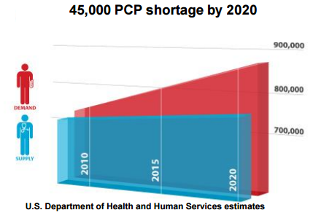It is increasingly difficult for patients to receive quality healthcare. This is mainly because there is an increase in the number of people without access to healthcare with a simultaneous dearth of primary care providers in the coming years.

The US Department of Health and human services estimates that by 2020 there will be a shortage of 45,000 Primary Care Providers(PCP). This puts an enormous strain on the industry to optimize the services that are being provided to offer the same quality of service with fewer care providers.

Figure 2‑1 Shortage of PCP- source

On the other end of the market, over 30 Million Americans do not have access to healthcare either due to a lack of insurance or due to inadequate coverage with up to 4.5% being unable to access healthcare due to affordability. People aged 25-34 were the most affected by inadequate coverage with almost 18% lacking coverage [1].

### Healthcare Spending

America is struggling with rising health care costs without a perceivable impact on outcomes. U.S. spending is highest in the world at an average of over $9,086 per person annually with a corresponding life expectancy of 78.8 years while the second highest spender is Switzerland at $6,325 per person but with an increased life expectancy of 82.9 years. Incidences of chronic conditions were also higher in the U.S. [7].

This problem is however just the tip of the iceberg. Deductible costs in health plans remain high. Therefore, patients delay care due to high cost and lack of access this leads to costly complications and/ or readmissions.

### Technology Capabilities

Technological advances in the past decade also have a major effect on improving access to telehealth. High-speed internet access even in remote locations has served as a catalyst for the telemedicine boom. In the following section, we will try to capture these trends that are driving the telecom market in more detail. There are also further technological advances in terms of Mobile Healthcare, Data analytics and even Artificial Intelligence that has led to a burgeoning environment that is enabling companies to launch disruptive products that can revolutionize the healthcare industry. Hardware commoditization and improved software platforms also serve to enable greater access to these technologies. These topics would be covered in greater detail in the subsequent chapters of this report.

## Trends

The Telemedicine is still in its growth stage reaching the end of its quantitative growth stage and on the cusp of quality growth this implies two things, (i) The industry is mature enough to warrant investment to capitalize on the quality growth and (ii) The industry has developed certain trends that the hospital industry can adopt to ensure a great return on investment. Some of the most important trends are listed below [8].

### Commoditization of Hardware

The industry has moved from proprietary devices such as robots in the first generation of telemedicine to more commoditized hardware. Proprietary hardware paved the way for the adoption of telemedicine in the quantity growth phase but with maturity, hardware has been commoditized. This enables the use of off-the -shelf PC components to achieve similar or better service.

### Common Software Platforms

The software that supports telemedicine has ceased to be a one trick pony and now integrates different aspects of telehealth such as synchronous or provider to provider. This also improves administrative efficiency and reduces overhead for the hospital.

### Adaptable Clinical Apps

Telemedicine technology has traditionally been focused on specific functionality but this doesn’t match with the care provider’s specific needs as each doctor has their own approach towards treatment. Telemedicine apps have therefore begun accommodating these requirements and have made highly adaptable applications.

### Electronic Medical Record (EMR) Integration

The Patient’s medical record has become more integrated across the industry. telemedicine providers are changing how they store information to enable access of data across different platforms.

### Data Analytics

Analytics of patient data is no longer a ‘nice to have’ feature, it has become more indispensable in making an accurate diagnosis and supporting care for the patient. This topic will be covered in greater detail in Ch 4.

## Implications for Hospital Industry

As mentioned in previous sections, telemedicine is an upcoming and burgeoning industry in and of itself, it is going to grab an increasing share of the healthcare spending irrespective of adoption by hospitals. Though a lack of active support and adoption from the hospital industry will slow the growth of telemedicine, it will not stop it. The impact on the hospital industry, however, would be more pronounced.

### Threat and Opportunity

The hospital industry is in the un-coveted position of being disrupted. Figure 2-2 shows the cost of the cost of the telehealth\ telemedicine industry’s costs as compared to that of the hospital industries cost. The profit margin and the wages for the hospital industry are much lower than that of the telemedicine industry. This in effect gives care providers an incentive to work with telemedicine more. Further, it opens the schedule of care providers to work with more than one hospital reducing their negotiating power even further.

However, there is also an opportunity for the hospital industry at this current time. The telemedicine industry is still relatively nascent but it has matured enough to warrant investment at relatively low risk. If the Hospital industry embraces the telemedicine technology, then they have an opportunity to control the development of the telemedicine industry and use its growth potential to improve services and thus capitalize on the cost efficiencies offered by the telemedicine technology. This further improves the quality of service and access to healthcare across the industry, which would be much welcome news.

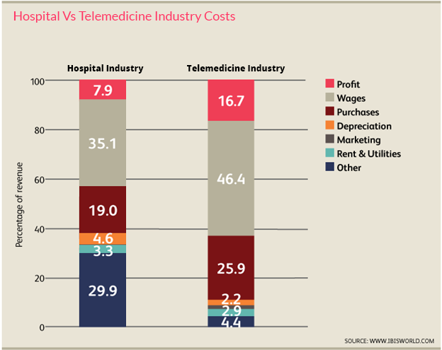

Figure 2‑2 Hospital Vs Telemedicine Industry costs

## References

1. "Chronic Disease Overview." "Access to Healthcare." Centers for Disease Control and Prevention. Centers for Disease Control and Prevention, 23 Feb. 2016. Web. 20 Apr. 2017.
2. Gerteis J, Izrael D, Deitz D, LeRoy L, Ricciardi R, Miller T, Basu J. Multiple Chronic Conditions Chartbook AHRQ Publications No, Q14-0038. Rockville, MD: Agency for Healthcare Research and Quality; 2014. Accessed November 18, 2014.
3. Wootton, Richard. “Twenty Years of Telemedicine in Chronic Disease Management – an Evidence Synthesis.” Journal of Telemedicine and Telecare 18.4 (2012): 211–220. PMC. Web. 21 Apr. 2017.
4. Herman, Bob. "More insurers are embracing telehealth, but Medicare adoption is still low." Modern Healthcare. N.p., 20 Feb. 2016. Web. 21 Apr. 2017.
5. Singh, Atul, and Amy Clark. Total Store Expo. Total Store Expo. Web. 21 Apr. 2017. <http://tse.nacds.org/Portals/0/2016/Presentations/TSE16%20Telehealth.Final.pdf>. Presentation Extract
6. Morea, Stephen. IBISWorld Industry Report OD5775. Rep. no. OD5775. N.p.: IBISWorld, n.d. Print. Telehealth Industry report
7. "US Spends More on Health Care Than Other High-Income Nations But Has Lower Life Expectancy, Worse Health." The Commonwealth Fund. N.p., 08 Oct. 2015. Web. 21 Apr. 2017.

**Author: Sridhar, Arjun**

# Mobile Healthcare Technology

The Doctor who travels with you.

The number of people using mobile phones in the U.S is more than the number of people having access to a proper healthcare facility.

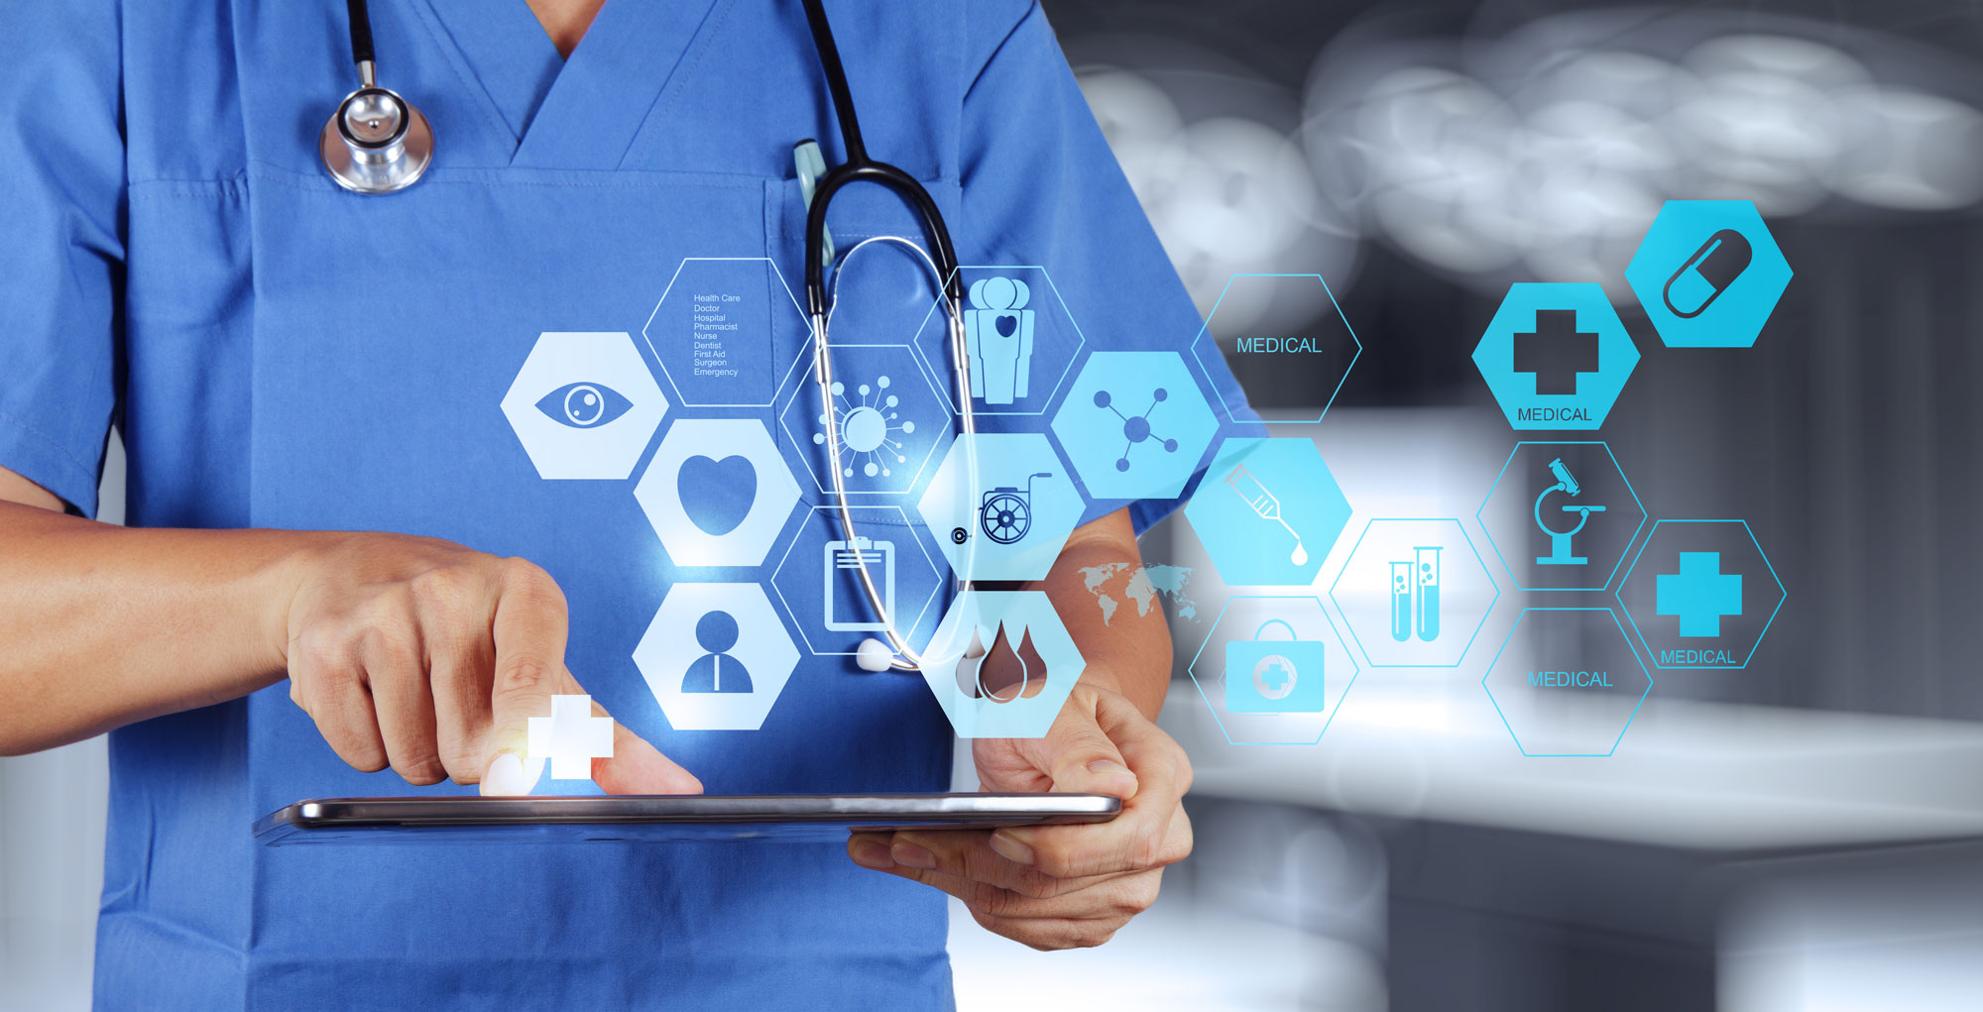

## Introduction

The use of mobile apps for health care related practices is becoming more and more inevitable. It is fair to say that mobile apps in this field are not ground-breaking anymore when it comes to practices like health record maintenance, communication and consulting, and information gathering. Apps for these functions have been around for nearly over a half a decade now. In this section of the report, we concentrate on the use of mobile apps for clinical decision-making by Health Care Professionals (HCP) and for medical education and training of the patients.

## Nature of suggested healthcare-related mobile application:

The number of people having access to healthcare in the world’s developed countries is less than the number of people having mobile phones. This is an instance of the numbers being too alarming for the healthcare industry to not do anything about. There needs to be a way in which basic health care is provided over the mobile phone. In this report, we suggest a triage system in the form of a mobile application. This app is loosely based on an application designed and developed by Dr.Charles Douglas, Assistant Professor of Pharmaceutical Sciences, Texas A&M University. The objective of this application is to suggest over the counter medication designed for users with varying levels of education. This application would have the potential to replace visits to the pharmacists by recommending the type, brand, and the dosage of drugs for simple ailments. The user interface of the proposed app would be simple in design to make it equally usable to all people irrespective of their level of education.

The app would analyze the millions of symptoms of the users and would decide if the user should visit a doctor or wait a few days or go to a pharmacy. The application has the following features.

* The app is designed to support multiple languages like English and Spanish to ensure that it becomes usable to a host of individuals with varied language preference.
* The app initially captures basic information of the user like age, gender, weight, and if the patient is pregnant before suggesting recommendations.
* An image of the human body is included that would let the users point at and choose the body part pertaining to the symptom.
* The app poses a list of questions about the history of ailments pertaining to the body part chosen.
* Images or symbols are used in most of the above-mentioned fields to support people with a reading-disadvantage.

## Useful performance:

### Potential Market:

Although the basic idea of this application has already been explained, it ideally needs to be tailored to cater to the needs of the different places where it will be put to use. Different versions of this application based on the different places of use are as given below.

#### Hospitals

Doctors are not going to be replaced by technology in this lifetime. The objective of this application is also not anywhere close to an attempt towards doing that. Most of the top hospitals have a version of their brand’s mobile application available on Appstore or the Play Store. Hospitals can consider adding the application described above as a feature to their existing app. This is capable of saving the time of both the patients and that of the doctors on simple ailments which doesn’t need a doctor visit. The hospital can make this service available for a subscription charge on a premium membership in the app.

In addition to this feature, hospitals should consider boosting their existing application with a patient monitoring system. Fitness trackers are a good way to assist doctors in their decision systems. Fitness trackers keep track of heart rate, distance traveled, speed, calories consumed and even the sleep patterns. This information tends to be vital for the doctors to assess and even diagnose illness. According to a Gartner study [2], over 68 million fitness tracker devices were sold in 2015. There was a sharp 36% rise in this number in the year 2016. The hospitals should watch this trend closely in order to incorporate this technology into their patient monitoring plans.

#### Vending machine:

The mobile app version of the application could be extended to a medicine vending kiosk that could dispatch medicines recommended by the application. The major objective of the kiosk version of the application is to ensure the access to the medicines during the after-store hours. Also, these medicine vending kiosks could be installed in public places like airports or in places with no pharmacies around. The technology for vending machines is readily available. The application needs to just be incorporated in the system with a large touchscreen feature. Pharmacies could consider licensing this application and set up a kiosk version of their pharmacy in places where their physical stores are not located.

#### Affordable Care Organizations:

Accountable Care Organization(ACO) is a health care organization with the objective of providing quality health care facilities at affordable prices. They are responsible for striking the right balance between the cost and the quality of the medical service provided. One of the stand-out features of the application suggested is its ability to reduce the spending on unnecessary doctor visits[3]. This cost-saving aspect of the application would be highly impressive from the perspective of ACOs. They can license the mobile application and can provide exclusive access rights to the individuals signed up with the ACO.

#### Large Retail Stores and Independent pharmacies:

Independent pharmacies and large retail stores like H.E.B and Walmart could consider licensing this application. There are two ways in which this application could be used by these stores.

The first of the two ways is on the similar lines as that of kiosk machines. In pharmacies which tend to get really busy, the touch screen kiosk version of the application could be installed. People could use these machines instead of waiting to visit the pharmacists. Additional features like the display of aisle number of the medicine’s location can be added to assist the users to locate the medicine with ease.

Another utilization of such an application to the independent pharmacies is that they can license these mobile applications and can distribute them to the users along with their existing application. They can have these applications suggest medicines of their brand, thus providing additional useful features to their existing application and also promoting their brand of medicines. This will also help them compete better with other established pharmacies.

### Complexity

One complexity that has been identified with this application is the disturbance to a well established existing system especially with the Accountable Care Organization (ACO).

The ACOs use a capitation payment model. By this payment arrangement, the Accountable Care Organizations have agreed to a tie-up with the health care providers with respect to the payment. They pay the doctors an agreed upon sum of money irrespective of whether the patients take their service or not. Based on the history of ailments of the patient, this sum tends to vary. The price works out to be reasonable for individual patients who are signed up with the ACOs.

With the introduction of this application where the patients have the option of skipping the doctor visits, the ACOs would ideally want to reduce the payment to the doctors. But there is no guarantee that all the patients signed up with the ACO would trust the app’s recommendation over the visit to the doctor. So this means that the doctors might still continue to provide the same service in spite of receiving a reduced pay. The health care providers might not be in agreement to this. So the ACOs will have to go for an alternate payment model if they are going ahead with the introduction of the application to its patients.

Also, before adopting this technology, it is not easy to determine if the customers would be willing to leave something as important as their health in the hands of technology. This makes things a little more complex for the hospitals and pharmacies when it comes to the decision to opt for this technology. Also, winning the trust of the patients is not an easy task. People would still prefer the human element when it comes to matters like health care. They should be provided with substantial evidence about the credibility of such an app before expecting them to start using it. iTriage is an app that comes close to the functionalities offered by suggested the application [4]. This particular app has been rated highly on the play store and has the “rated by Harvard” certification on it. This makes the app all the more credible. On similar lines, in order for the suggested app to win the trust of the people, it should have approval and certification from several credible institutions- more the better. This adds to the complexity of coming up with this concept.

## Cost and time analysis

An extensive cost and time analysis should be carried out before an organization ventures into developing any mobile application. The cost of development of a mobile application depends on various parameter like the complexity of the application developed, the number of resources working on the development, geographic location of the resources, supported devices and Operating Systems, estimated post-launch maintenance [5]. One of the major contributing factors for the developmental time and cost of the application is the complexity of the back-end server. The difficulty level of developing mobile apps can be classified as low, medium and high based on the complexity. A simple stand-alone mobile app takes around 3-4 weeks of development time while an application with a high level of complexity takes around 3-5 months of development time assuming 4-6 resources are dedicated for its development and testing purposes.

Although the basic form of the proposed application does not require the users to create a profile and log in to access the features, the version which tracks the health with the help of fitness wearables does require the user to create an account. This adds to the complexity of the already existing database containing the combination of symptoms and remedies based on age and gender. These aspects contribute towards qualifying this application as a complex mobile app. The cost of development of this complex mobile app is around $50,000 to $80000 assuming that the developers charge a sum of $50 to $80 per hour based on their level of expertise. If the app is intended to be supported on both iOS and android OS, the resources on the back end database can be saved since the database is shared by both the application.

Pharmacies would want to install the application on vending machines for the kiosk version. The cost of development of the application remains the same. As far as the vending machines are concerned, the pharmacies may consider leasing the vending machines initially. They can consider buying the machines based on the success of the application. The cost of leasing a vending machine is around $120 per month for a 2-year lease [6].

This is a one-time investment with a relatively lower charge to go with it on the maintenance of the application. The return to the hospitals on an investment on mobile apps is the improvement in the quality of service provided to the patients with help of the triage system. Also, the subscription charge for a premium account on the hospital’s official app adds to the return on investment. The pharmacies investing in this technology can increase their customer base by getting more people to use the services on their official app thanks to the new functionality provided. This increase in business is their return on investment.

## Implementation Challenge

Since this implementation is a first of its kinds, there are various challenges involved which needs to be overcome before successfully carrying out the implementation.

### Testing of application

One of the major challenges with the implementation is the testing of the application. With so many millions of combinations of symptoms and parameters to be taken into consideration, an extensive and comprehensive testing of the application is needed. It is impossible to determine with certainty if all the combinations are accounted for and if the drugs recommended are indeed right. So an extensive team of testers who have experience in the field of medicine is needed. This is highly challenging to implement.

FDA regulations:

The U.S Food and Drug Administration (FDA) has always encouraged the adoption of ways that helped provide better health facilities to the people from all walks of life. They have been supportive of the use of technology that ensures both the patients (consumers) and professionals in health organizations with health care awareness and information. In spite of these facts, one of the key aspects of their job is to ensure safety in medical practices and to mitigate risks involved. [7] The mobile applications for health care related purposes are categorized under medical devices since these applications are used on smartphones or tablets. This brings these applications under the oversight of the FDA for the assessment of risk and effectiveness. For the medical devices to be certified as usable by the people, there are several guidelines that need to be adhered to apart from enforcing the submission of a premarket review application. In spite of the fact that the mobile apps are considered as low-risk medical devices, FDA exercises enforcement discretion to these apps. There is a clause as a part of the discretion, that has several sets of norms for apps that use patient characteristics like age, sex, and behavioral patterns. One of the clauses clearly states-

“This enforcement is applicable for mobile apps that guide a user through a questionnaire of signs and symptoms to provide a recommendation for the type of health care facility most appropriate to their needs.”

The application proposed by us exactly matches this description. The developers (business and technical unit of the team) of the application are expected to be aware of these norms before working on this application. The application development team should work closely with the legal team to ensure that all the rules are adhered to. This adds to the implementation challenges of the application.

## References

1. Matchar, Emily. “Could this app replace your doctor” http://www.smithsonianmag.com/innovation/could-app-replace-your-doctor-180958467/
2. Anonymous. “The next wave of fitness wearables will send data directly to doctors” <https://qz.com/467145/the-next-wave-of-fitness-wearables-will-send-data-directly-to-doctors/>
3. MedAnaytics. “Accountable Care Organization Technology Framework” <https://www.healthitoutcomes.com/doc/accountable-care-organization-technology-framework-0001>
4. Anonymous. “iTriage Official”< <https://www.itriagehealth.com/mobile>>
5. Anonymous- “How Long Does it Take to Build a Mobile Application?” < http://www.seguetech.com/how-long-does-take-build-mobile-application/>
6. Anonymous “Vending Machine Sales and Leasing” < http://www.vendingsolutions.com/vending-machines-sales-and-leasing>
7. U.S Food and drug administration- Offical site.

<https://www.fda.gov/MedicalDevices/DigitalHealth/MobileMedicalApplications/ucm255978.htm>

**Author: Rao, Srivatsa**

# Big Data Analytics and Decision Support

A game changer in healthcare

Data is present all around us and is particularly abundant in the medical and research field. Harnessing this information to deliver better healthcare services can be achieved with the help of Big Data.

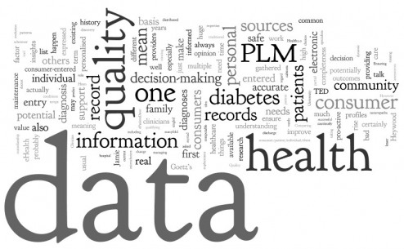

## Introduction

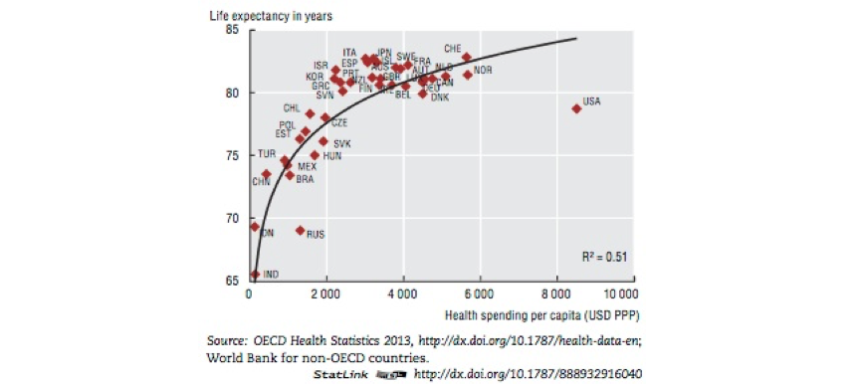With the advent of Big Data, early adopters have found an increasing need for it in the healthcare sector. Based on findings and data analysis by OECD Health Statistics 2013, USA is one of the highest spenders on health care benefits despite a lower life expectancy rate compared to other countries (Fig 4-1). At its current rate, the U.S. spends nearly $3.3 billion on national health care and expected to increase to $4.1 billion by 2020 [1]. Based on a 2013 National Health Expenditures, hospital care accounts for 40.66% of the total expenditure which is the most of any other health care service. Healthcare expenses account for ~18% of the nation’s GDP [7]. With increasing expenditures on Medicaid and Medicare, solutions to better health care quality and reduce costs is paramount. Proponents of Big data believe there is an increasing need for its use in the healthcare domain which can help reduce costs for hospitals and aid doctors in clinical diagnosis.

Figure 4‑1 Health Statistics 2013: Health spending per capita vs Life expectancy in years

## Value-based Care

The purpose of this system is to provide patient-centric care of the utmost quality. Additionally, efforts are to be taken to reduce healthcare costs, improve healthcare quality, avoid reuse and support for payment structures. Several health care insurance agencies are currently using a fee-for-service based system which they hope to switch to a value-based system depending on the quality of healthcare service provided. With this system, the payment structure is more streamlined, more care given to 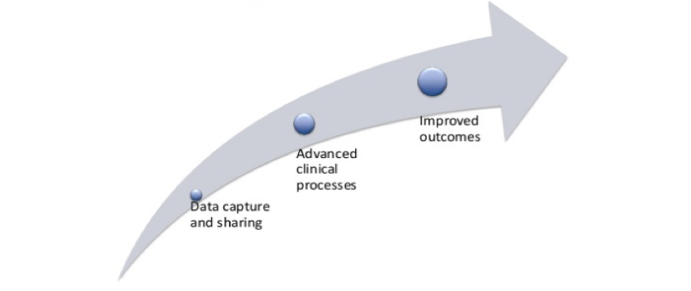avoiding medical errors, reducing readmissions, and making care-based organizations accountable. Fig 4-2 and 4-3 represent this.

Figure 4‑2 Value based care

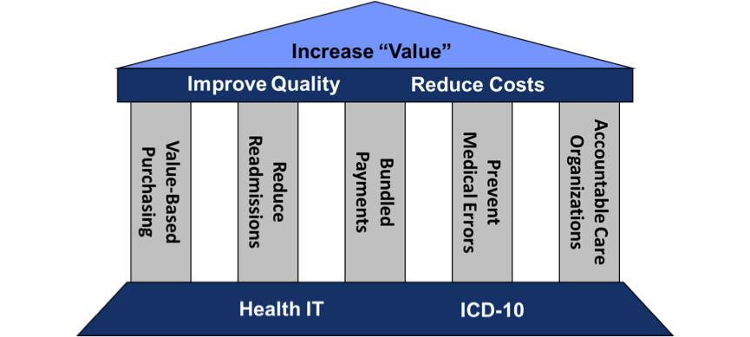

Figure 4‑3 Value-based Care – What it achieves

## Clinical Decision Support (CDS)

Information which can help improve health and health care of patients is called clinical decision support. Doctors and clinics rely on this data to diagnose and provide better treatment to patients. There are various tools which aid in the diagnostic decision support system which includes formal documentation, proper patient records, diagnostic support, and telediagnosis. In the same vein as value-based care, CDS aims to reduce errors, improve health care quality, increase efficiency and provide cost-effective means. For CDS to be successful it is vital to perform a systematic analysis of data. For this, Telemedicine and Big data analytics can help immensely. Use of these technologies can not only improve patient care but also reduce costs for the hospital. Maintaining a central autonomous CDS system or comprehensive EHR systems is essential in collating the volumes of healthcare data. [3]

## What constitutes healthcare data?

The following list of sources constitutes most healthcare data:

* Medical device data
  + Scans, Imaging, Tele-diagnostic, Bioassay results, mobile healthcare devices (Fitbit, pacemakers, defibrillators)
* Claims
  + Documents from insurance agencies
* Pharmaceutical/ R&D data
  + Clinical trials data, bioinformatics, genomic data
* Electronic medical record data (EMR) or Electronic Health record data (EHR)
  + Patient data, clinical data, patient history, behavioral, prescriptions, lab tests – acquired because of Medicaid and Medicare

With current technology, various devices which are wearable on a regular basis or used for testing purposes (blood sugar) can generate valuable data which can be collected and analyzed. Data over a span of time can provide vital information about a person’s state of mind, well-being, lifestyle, etc. This, in turn, can lead to better methods of diagnosis.

## Big Data trends in Healthcare

Technology has played such a big role in hospitals with recent use of robotics and cutting-edge technology firms such as IBM have bet on the positives of using analytics, algorithms and machine learning in healthcare. [6] With the adoption of IBM Watson, healthcare facilities can make use of Watson’s voluminous databases and artificial intelligence system to manage various departments, provide better patient care, reduce costs and drive effective health care frameworks. Big data analytics has become a dominant force in several streams these days. Its use in healthcare is particularly useful as doctors and practitioners can use this data to manage high-risk and high-cost patients [5]. Based on recent studies, big data can be used to reduce costs through different opportunities such as “high-cost patients, readmissions, triage, decompensation (when a patient’s condition worsens), adverse events, and treatment optimization for diseases affecting multiple organ systems.” [5]

### Real-time monitoring of patients

Wearable devices and medical devices constantly emit data of a patient’s health condition. Creating dashboards and providing mobile analytics or alerts by way of machine learning algorithms and analytics can help doctors analyze a patient’s well-being and provide the next best possible course of action. Data from these devices can be analyzed by using modern technologies such as Apache Spark, Hadoop or Hive to give accurate information about a patient. Because of these opportunities, physicians can monitor a patient’s health condition real-time and can prescribe tests or medicines accordingly. Use of these wearable sensors can also help avoid the face-to-face interaction with doctors. In this way, patients can alert doctors of any irregularities via the device and the latter can administer care based on the device data.

### Predictive analytics

Electronic health records (EHR) consists of vast unstructured data which grows at a rapid rate. Predictive models are used to catch early symptoms of diseases which are genetic or those which have a high mortality rate such as Congestive Heart Failure (CHF). Predictive modeling goes through several phases before the final prediction is attained. Data is passed through various machine learning algorithms and tested to arrive at a model. Each test is scored and the eventual prediction with the highest score is the one which is closest to predicting the outcome of a given medical test. To carry out a predictive analysis, a large sample size of data is needed to form patterns and refine the prediction algorithm. Predictive analytics also plays a role in fraud detection and abuse. Using this system fraudulent activities pertaining to Medicare or Medicaid payments can be identified. [8]

### Eliminating abuse and fraud

One of the key advantages of using Big Data and analytics is that it can help in reducing and eliminating abuse and fraud of healthcare services. Using predictive analytics, machine learning and algorithms it can be used to identify fraudulent activities, for example, use of prescriptions in different locations for a given patient, receiving services for the same issue and patient from different locations, overusing of hospital resources. Implementing technology like Hadoop can help sift through volumes of unstructured hospital data which can help reduce costs and identify anomalies. Algorithms and anomaly models help reduce the risk of fraud and verifies if claims or billing patterns are suspicious. [2]

### Internet of things (IOT) & Healthcare

Internet of things for healthcare is essentially what we have discussed so far: volumes of unstructured data from various sensors and wearable devices which can be used to improve patient healthcare. There have been heavy investments in this field by utilizing technologies such as Hadoop and IBM Watson. As seen earlier, data gathered from these devices can help reduce costs, reduce direct interaction with doctors or alert doctors of abnormal spikes in symptoms.

## How can this be achieved: Big Data architecture?

We have so far discussed the benefits of using analytics, predictive models, machine learning algorithms and modern technology such as Big Data to improve health care. To achieve this, systematic collection, analysis and testing of data is essential. A concrete architecture and system are required in this regard. As seen in Fig 4. we would need to perform the following processes [2]:

* **Data sources**: Identify sources of medical data – wearable devices, sensors, medical devices, social media, EHR, claims, prescriptions.
* **Collect data**
* **Process data:** Sift through unstructured data from all devices and arrange them in a structured manner. This stage helps in identifying which part of the data is useful for further investigation.
* **Store data:** Using NoSQL databases or distributed frameworks such as Hadoop can help maintain large sets of data.
* **Serve data:** Deliver data via dashboards, devices or process through machine learning to derive more results.

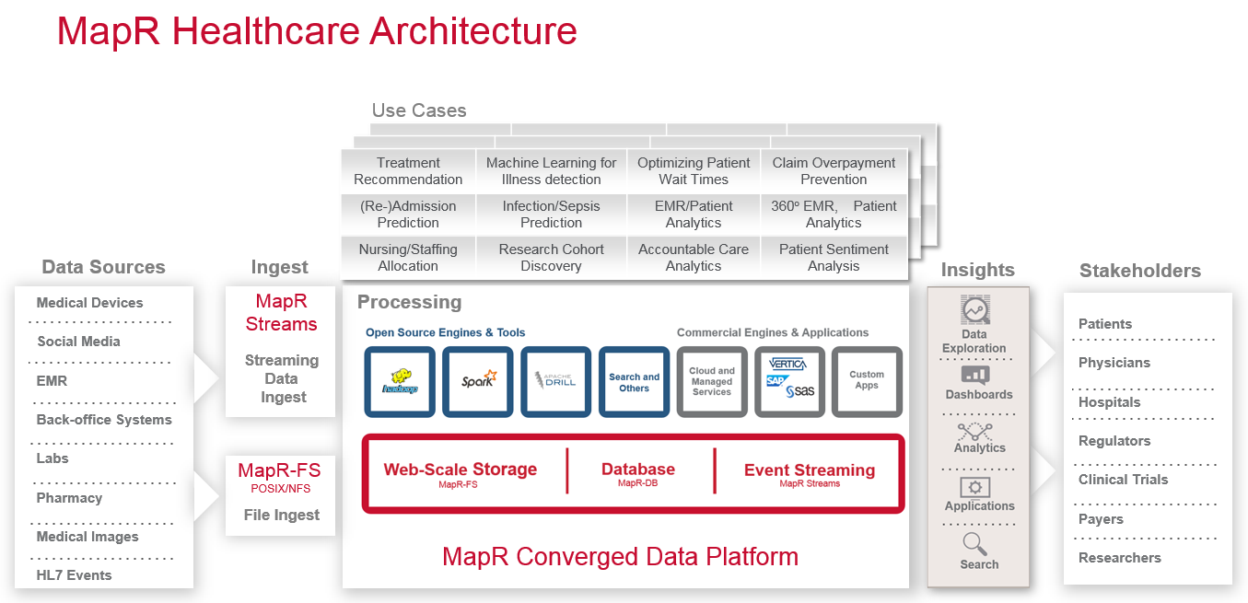

Figure 4‑4 Architecture

### Power of NoSQL Databases

One of the problems in using a relational database management system (RDBMS) in place of a NoSQL database is that it is difficult to manage volumes of data. Since data from the data sources identified in the previous section is critical, we need to implement an easier method to maintain this data. NoSQL with its de-normalized schema structure helps avoid querying a large number of tables and resulting in a bottleneck. Several experts believe that MapR-DB is suited in handling this issue [2]. By forming clusters and partitioning the data into them, it easily avoids the bottleneck issue seen with RDBMS. Using specific API’s, the data can be refined and delivered in the desired format.

### Use of Hadoop and NFS

Hadoop and specialized API’s such as Kafka, HDFS, HBase, and JSON have gained traction over the years. It has been the focal point for the healthcare industry in recent years. UnitedHealthCare, in 2015, decided to implement Hadoop to rectify the fraud and abuse issue seen with claims and payment structures in the healthcare industry [9]. By incorporating an enterprise system, it helps reduce risk and costs. Another use of Hadoop with the network file system (NFS) helps access data available on several remote servers. MapR coupled with NFS allows fast read and write access which results in faster manipulation of data and generation of analytical reports. Data ingestion i.e. absorbing data from different sources can be achieved using MapR streams. This distributed messaging system uses the Kafka API where data messages are stored in different partitions as topics. By maintaining topics across a large number of servers, scalability is achieved and the issue of slow read/writes of real-time data is not present. The topics can be consumed by different distributed channels and used for different purposes.

A few benefits of using MapR DB are its security, low administrative overhead, and real-time operational analytics capabilities [10]. As seen in section 5.5, we have identified the data sources and data collection methods. To process the data, we can perform one of two methods [2]:

* Batch processing
* Stream processing

The first method processes data in bulk while the second takes data from streaming events (medical devices, wearable devices, mobile). With the first method, technologies such as Apache Hive or Spark can be used to process the data. Stream processing can be achieved via Spark streaming or Apache Storm. Storing of data can be performed using a NoSQL database which is ideal. Finally, because of data mining methods, we can deliver the data in the form of dashboards and reports. Technologies like Apache drill and Spark can be used to achieve this. This entire phase from identification of data sources to delivery is run on the MapR Converged Data Platform [2].

## Proposed architecture

Different system architecture setups can be implemented depending on the desired outcome. If we were to implement a system where data is collected from various sources and the output can be manipulated as needed, a MapR architecture can be implemented as seen in Fig 5. We believe by implementing this architecture, data can be ingested and stored using the MapR converged data platform. Other case-based architectures which can be employed are [2]:

* Data lake architecture
* Streaming system of record for healthcare
* Genome processing

The data lake architecture is a form of MapR architecture which uses the MapR converged data platform on top of the Apache Spark features. Here, the enterprise storage, database, and event streaming, communicate with Spark and the drivers for further data exploration (Apache Drill).

The streaming system brought on by Liaison Technologies is secure as it strictly meets HIPPA standards and handles multiple data formats very well. The event stream can be handled in any format, JSON, graphs or search-based and will always show the most current events to the end user. Thus, real-time event streaming is possible and is secured well.

Processing and analyzing large sequences of genomes based on MapR and handling the output using Spark is the core concept of Genome processing.

In closing, we believe a planned execution of many of the sections discussed in this chapter is a stepping stone for many hospitals in the industry. Adopting value-based care, CDS and a structured plan for Big Data architecture implementation are essential towards achieving an improved level of healthcare standards and care.

## References:

1. Plunkett, Jack W., Martha B. Plunkett, Jill S. Steinberg, Jeremy Faulk, and Isaac Snider. "U.S. Health Care Industry Statistics and Market Size Overview." Health Care Industry. Plunkett Research Online, 21 Oct. 2016. Web. 22 Apr. 2017. <http://www.plunkettresearchonline.com>
2. "How Big Data is Reducing Costs and Improving Outcomes in Health Care." How Big Data is Reducing Costs and Improving Outcomes in Health Care | MapR. N.p., n.d. Web. 22 Apr. 2017.
3. HealthIT.gov. N.p., n.d. Web. 22 Apr. 2017.
4. "5 Big Data Trends in Healthcare for 2017." 5 Big Data Trends in Healthcare for 2017 | MapR. N.p., n.d. Web. 22 Apr. 2017.
5. Bates1*, David W., Suchi Saria2, Lucila Ohno-Machado3, and Anand Shah4 And. "David W. Bates." Health Affairs. N.p., 01 July 2014. Web. 22 Apr. 2017.
6. "Industry trends, Artificial Intelligence (AI), Deep Learning and Machine Learning Advance into Commercial Applications, Including Health Care and Robotics." Plunkett Research, Ltd. N.p., n.d. Web. 22 Apr. 2017.
7. Basel Kayyali, David Knott, and Steve Van Kuiken. "The big-data revolution in US health care: Accelerating value and innovation." McKinsey & Company. N.p., n.d. Web. 22 Apr. 2017.
8. "Predictive analytics play a new role in fraud detection, but critics want more." Modern Healthcare. N.p., n.d. Web. 22 Apr. 2017.
9. "Hadoop in Action: Using Hadoop to Detect Fraud, Waste, and Abuse in Healthcare." Hadoop in Action: Using Hadoop to Detect Fraud, Waste, and Abuse in Healthcare | MapR. N.p., n.d. Web. 22 Apr. 2017.
10. "Hadoop NoSQL Databases - MapR-DB." In-Hadoop NoSQL Databases - MapR-DB | MapR. N.p., n.d. Web. 22 Apr. 2017.

**Author:** Shrivastava, Nikhil

# Security

Protecting the data that protects you

Medical records are at the core of your privacy in healthcare and they need to be kept secure and confidential, always. It is quintessential to devise innovative information security solutions to keep these records from harm’s way.



## Introduction

With an increasing availability of low cost and efficient information systems, more and more organizations are digitizing the way of doing their business. As can be seen in every other field, this wave of information technology has swept across the field of healthcare as well and has brought about a massive change. As discussed in the preceding chapters, the healthcare industry is following a similar approach. The very essence of this transformation lies in the digitization of health records, by bringing about a gradual shift from reliance on paper-based records. While following this approach, we have advanced to such an extent that we now use information systems to not only maintain patient records but to also administer patients remotely through telemedicine, mobile healthcare applications, etc. At the same time, we are utilizing the potential of big data and analytics to enhance our ability to manage and perform computations on huge volumes of data that technologies mentioned above generate. Not only have these technologies helped in providing healthcare services in an effective and efficient manner, but it has also helped in bringing down costs.

Even though information technology has helped make health care services much more accessible and affordable, it has also increased the susceptibility of these services to fraudulent activities. The technologies mentioned above have risks of their own, which, if not mitigated, might have catastrophic consequences. Confidentiality associated with medical records complicate matters further. In extreme situations, it can lead to loss of life, thus defeating the very purpose of providing health care services. As more and more modern day hospitals move towards utilizing information technology for providing services, it is becoming exponentially difficult to monitor their activities and protect them against frauds, cyber-attacks, data breaches, etc. Refer figure 1 in the appendix.

## Confidentiality, Integrity, and Availability (CIA): Why are they important?

Confidentiality, integrity, and availability or CIA form the basis of any information security policy designed today. Confidentiality refers to keeping information private and secure. Integrity involves keeping information reliable and accurate, and availability involves keeping the system up and running always. We describe these three pillars of information security with respect to hospitals below.

We, as humans, are often hesitant about revealing personal information fearing that it might affect our day-to-day life. We only do so when we are promised confidentiality. This applies to health care as well. To maintain a healthy physician-patient relationship and facilitate a successful treatment, it is important that information pertaining to an individual’s health is kept confidential. Maintaining this reliable environment is extremely important as it helps build confidence in the physician-patient relationship. Thus, the patient is more than willing to share sensitive information about his/her well-being, which is the stepping-stone of receiving effective care. The need of maintaining this confidentiality coupled with the susceptibility of information systems to frauds and data breaches only adds to the worry of an organization trying to establish itself in the field of healthcare.

At the same time, it is essential that an individual, who is authorized to access the hospital information systems, receive information that is accurate and reliable. Any discrepancy in a patient’s medical record might lead to ineffective treatment. In worst-case scenarios, it might also lead to loss of life. Integrity is, therefore, extremely essential for the seamless functioning of a hospital.

An individual may need healthcare assistance at any time during the day. It is, therefore, essential that systems be maintained to function effectively and efficiently 24*7. Continued availability is, hence, essential.

In this regard, the US government has enacted various laws and regulations that safeguard a patient’s rights and help keep their information secure. A few of them are discussed briefly in the section below.

## Legal Requirements and Implications

US government requires organizations operating in the healthcare domain to be compliant with a few laws. To function effectively and legally, it is essential for a healthcare organization to be acquainted with these. Therefore, we have provided a brief overview of major healthcare laws like *Health Insurance Portability and Accountability Act of 1996 (HIPAA) Privacy and Security Rule* and *Health Information Technology for Economic and Clinical Health (HITECH) Act* in the appendix at the end of this chapter.

Apart from the federal laws mentioned above, most states have state data breach notification laws of their own. An organization needs to be compliant with all of the above to be able to function legally within the US. [1]

## Information Security in Hospitals

Healthcare organizations compete to provide the best services in a streamlined manner while generating maximum revenues. Information systems aid them in this process. While using these systems, it is important to maintain confidentiality and prevent unauthorized access to sensitive information. In addition, as collaborating healthcare organizations, like the one providing treatment and the one providing insurance, interact, it becomes increasingly important that these organizations follow a standard approach, so that a minimum required consistency is maintained.

While most organizations believe that information security is a technical responsibility, it is important that we adopt a more comprehensive approach, where we cultivate an informed culture by training employees and educating them about policies to deal with information security and data protection risks. Strong emphasis should be laid on setting up administrative, technical and physical standards.

Per a survey involving IT managers working in hospitals affiliated with the top medical universities in the US as participants, administrative safeguards were found to be the most susceptible among the three safeguards mentioned above. Hence, it is important that hospitals incorporate comprehensive administrative procedures and policies. Extensive training should be provided to employees in this regard. Apart from upholding information security within the hospital, it should also be highlighted in contracts involving external organizations. At the same time, users should be educated about issues associated with information security. Though technical safeguards were assessed as robust, they should not be overrated. The hospitals should establish detailed policies in this regard. For physical safeguards, hospitals should define physical access protocols for entry into critical areas. [2]

## Healthcare security threats and mitigation

We will now discuss the most common security threats that most healthcare organizations encounter, and the steps needed to mitigate them.

### Employees

Internal employees can, unconsciously or consciously, pose a serious threat to the security of patient medical records managed and maintained by a hospital. Employees, if not trained adequately, might fail to abide by federal and hospital rules and regulations, ultimately jeopardizing the reputation of the hospital. On the other hand, there can be situations when an employee might go rogue and try to misuse systems for carrying out fraudulent activities. Training employees can handle the former. To safeguard hospital information systems against the latter, it is essential to maintain distinct access roles and profiles for employees working at different levels within the organization. Not only will this help in preventing misuse, it will make finding the potential cause of discrepancy easy if at all one occurs. We can also record employee habits to look for sudden deviations from standard routine.

### Medical Devices and Internet of Things

Medical devices are designed with the sole motive of aiding treatment. Enough emphasis is not given to securing these devices from potential cyber-attacks. As these devices grow more and more sophisticated, so is their susceptibility to these attacks. With the advent of Internet of Things, these devices have begun to interact with each other over a network. This network serves as the weakest link in this interaction. Imagine a scenario where someone hacks into your pacemaker. As scary as it may sound, this is possible in the current day scenario. Also, as most devices are manufactured and marketed by external vendors, enabling information security becomes even more difficult due to varying standards. Hence, it is important to establish principles like encryption and virtual private networks (VPN) to secure these devices.

### Mobile Health Applications

More than half a billion people use mobile health applications to receive treatment. With the ever-increasing adoption of smartphones, the number is bound to increase further. Moreover, most these applications fall outside the purview of HIPAA and HITECH, making it difficult to keep track of them. In addition, as these applications run on different kinds of mobile devices, manufacturers can gain access to sensitive data and pass it on to advertisers for monetary gains. These devices are also not completely secure. Hence, it is essential to establish consistent standards across all manufacturers to ensure compliance with privacy laws and regulations. It is also important to incorporate technical security safeguards for ensuring safe transmission of data across devices that are not secure. [3]

### Analytics

Big data and analytics help in analyzing information and use it to improve the operations of an organization. Generally, most of these activities are outsourced to a third-party vendor. Moreover, giving someone access to all your data can have serious repercussions. These threats can be mitigated using information control and real-time security analytics that predict potential threats and encrypting data to ensure that a patient’s identity is not disclosed. [4]

## Implementation Plan

As seen in the previous sections, the healthcare industry has been under constant pressure to come up with a standard procedure to enable information security. With recent advancements in the field of information technology like telemedicine, mobile health applications, etc., it has become increasingly difficult to come up with a policy that safeguards against all possible threats. Even though it is possible to mitigate most these threats, it is impractical to do so because of the costs involved. Moreover, information technology within healthcare is conventionally treated as a cost center and not every organization is willing to contribute equally. Thus, it is important to prioritize threats based on their cost and lethality, and develop an implementation plan, accordingly. Based on the threats discussed above, we have come up with the following steps.

### Categorize risks

As discussed previously, different segments within the healthcare industry have a different level of risk associated with them. Moreover, it is not feasible to mitigate each one of them. It is, therefore, necessary that we consider various factors like possible threats to an individual’s health, network connectivity, information vulnerability, susceptibility to attack, costs and third-party service level agreements, and categorize risks, accordingly.

### Design and deploy a functional risk management framework

It is important to establish a framework responsible for governing and stabilizing threats pertaining to information system security while complying with federal rules and regulations, as it helps in preventing mishaps and controlling their after-effects, if at all they occur. A governance, risk management, and compliance (GRC) software can be deployed to support this framework. GRC facilitates a methodical approach towards managing and minimizing risks across various departments within an organization. SAP, Oracle, IBM are a few major providers of GRC software. [5]

### Cultivate information security as a culture within your organization

Apart from establishing technical safeguards, it is extremely important that an organization raises awareness about information security among its employees and trains them on the same. As potential threats to the system grow more and more sophisticated, it is important that organizations update and revise their policies continuously.

### Incorporate security principles and standards in third party agreements

Third-party agreements have served as a bottleneck when it comes to information security for a very long time. Hospitals can ask their third-party vendors to include security guidelines while buying their devices. Hospitals can also ask vendors to perform penetration testing, disclose existing weaknesses within the system, suggest best practices and steps in case of an attack.

### Ensure compliance by developing a framework

It is important for a hospital to implement security throughout the system rather than just at entry and exit points. Proper authentication and authorization mechanisms should be installed everywhere. Monitoring data transmission also helps in finding unusual activity within the system. The use of technologies like virtual private networks (VPNs) and encryptions help in reducing the susceptibility to attacks further. [6]

These steps, if followed diligently, will help in developing and deploying a secure hospital information system.

## Cost Analysis

The cost of implementing an information security policy within hospitals can be derived by combining the costs associated with implementing administrative, technical and physical safeguards. Administrative safeguard implementation involves coming up with a comprehensive information security policy compliant with various federal rules and regulations. It also involves training employees. The costs associated will be approximately USD 100,000. Physical safeguards will cost another USD 50,000, approximately. Technical safeguards will include costs associated with hardware and software and will require an expenditure of close to USD 1,000,000.

## Appendix

### Health Care Privacy Laws

*Health Insurance Portability and Accountability Act of 1996 (HIPAA) Privacy and Security Rule*

The HIPAA Privacy Rule sets up federal standards to safeguard a person’s health records and related personal health information (PHI). It is applicable to health plans, health care clearinghouses, and health care providers that conduct certain health care transactions electronically. This rule defines the safeguards that need to be put in place to protect the privacy of PHI and steps to be followed before any information is disclosed to entities that do not have the necessary authorization to access it. The individuals who work with healthcare organizations are entitled to take precautionary steps to keep medical records secure. [7]

The HIPAA Security Rule establishes federal standards to secure electronic PHI (ePHI). It covers the administrative, technical and physical safeguards that need to be put in place to protect ePHI. The Security Rule is flexible and promotes data encryption.

A hospital or a physician’s office is most vulnerable to data breaches as it is where PHI is generated and fed into systems. As more and more organizations get involved in the process,

this information is transferred from one to another, thus enabling HIPAA. [1]  
*Health Information Technology for Economic and Clinical Health (HITECH) Act*

The law aims to improve the quality of healthcare services available in the United States by encouraging and enabling the use of information technology. They promote the use of electronic health records (EHRs) and a secure and private electronic health information exchange.

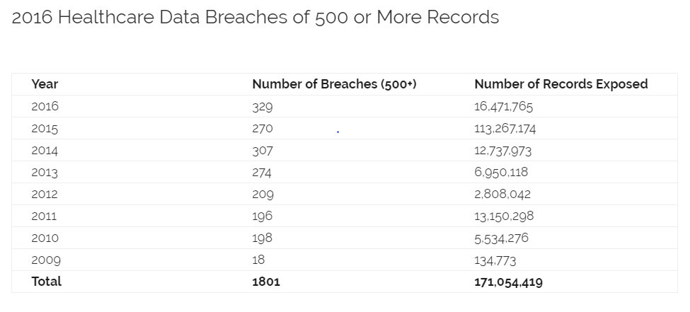

Figure 5‑1 Healthcare data breaches of 500 or more records

## References

1. Thomson, L. L. (n.d.). Health Care Data Breaches and Information Security Addressing Threats and Risks to Patient Data. Retrieved from <http://www.americanbar.org/content/dam/aba/publications/books/healthcare_data_breaches.authcheckdam.pdf>
2. Health Information Security in Hospitals: the Application of Security Safeguards Esmaeil Mehraeen-Haleh Ayatollahi-Maryam Ahmadi - <https://www.ncbi.nlm.nih.gov/pmc/articles/PMC4789743/>
3. 5 Problems With Mobile Health App Security David Pittman David Pittman - <http://www.medpagetoday.com/practicemanagement/informationtechnology/44161>
4. Patil, H. K., & Seshadri, R. (n.d.). Big data security and privacy issues in healthcare. Retrieved from <https://pdfs.semanticscholar.org/6220/ac5410c1c8f30e8865221a8695f0f7f5034f.pdf>
5. What is GRC (governance, risk management, and compliance) software? - Definition from WhatIs.com <http://searchcio.techtarget.com/definition/GRC-governance-risk-management-and-compliance-software>
6. 5 steps to cyber security for Internet of Things medical devices <http://www.healthcareitnews.com/news/5-steps-cybersecurity-internet-things-medical-devices>
7. Privacy HHS Secretary-Office (OCR) - <https://www.hhs.gov/hipaa/for-professionals/privacy/index.html>

Conclusion

In preceding chapters, we discussed how various technologies viz. mobile health applications, analytics, telemedicine, and security can help improve the provision of healthcare services within the United States, individually. In this chapter, we will discuss why is it extremely necessary to implement these technologies simultaneously to work towards the same goal.

## The Need for Change: Cost-Benefit Analysis

The biggest challenge that the healthcare industry faces today is cost. Despite several attempts by the government to cut down costs, it is projected that health care expenditure will grow at a rate faster than the US economy in the coming decade. The average expenditure per person is approximately USD 10,000 per year currently and it is expected to go up further. Also, due to the introduction of Affordable Care Act, there was an increase of about 17.6 million individuals who are covered under health care coverage by the first quarter of 2015. If this trend continues for some time, healthcare organizations will run out of business due to lack of funds.

In addition, even though the expenditure on healthcare is increasing exponentially, the quality of services provided by hospitals has been continuously deteriorating. When we compare the health system within the US with that of other developed countries, we realize that though the expenditure in the US is higher, the average life expectancy is not as high. The following figure gives a better idea about the same. [1]

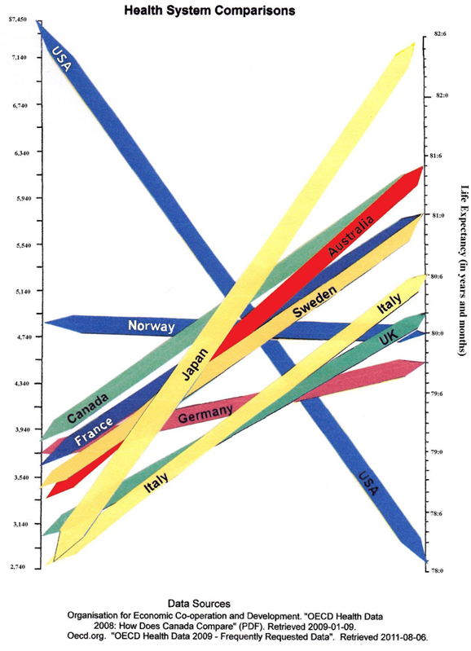

Figure 2 Healthcare costs vs Outcomes

Another challenge that the industry currently faces is the shortage of talented healthcare professionals. Though the demand for healthcare professionals was pretty low and showed almost no to little signs of growing, it shot up mid-2014. The average monthly employment in healthcare increased from approximately 13,000 in 2013 to 26,000 in 2014. For 2015, the same number was close to 41,000. During the same time frame, the number of healthcare employment grew by close to 500,000 jobs in a year. However, there were close to 100,000 unfilled positions. The demand has been on the rise and it has continuously outpaced the availability of skilled workforce ever since. The gap is widening at an ever-increasing rate. In such circumstances, it has become vital to come up with a solution that compensates for this difference. There could be two possible solutions. One, increasing the availability of trained health care professionals and two, increasing the number of patients a doctor can cater to. The former is a gradual process and would take longer to implement. The latter, however, can be implemented using technology. Alternatives like telemedicine and mobile health applications provide hospitals the ability to reach out to patients remotely. This will not only help in increasing the number of patients who get effective treatment, but it will also ensure that people in remote areas, with insufficient health care infrastructure, get treated successfully. At the same time, we need to ensure that these medical records are secure, which is where information security comes into the picture. [2]

Hospitals also face a significant threat from new entrants in the industry. Several entrepreneurial ventures and technology giants like Apple, Google, Samsung, AT&T, etc. are now trying to enter the healthcare industry as patients have become increasingly enthusiastic about trying out new and cheaper non-conventional alternatives. A survey conducted by PwC showed that out of 1,000 adults, close to 500 were interested in seeking medical treatment from non-conventional sources. They were also willing to use technology to receive treatments in the form of dialysis, chemotherapy, urinalysis etc. at a location other than a hospital. This change in mentality could lead to losses in the order of billions of dollars for a conventional healthcare organization. It is, therefore, quintessential that hospitals utilize technologies described in the preceding chapters to equip themselves with services capable of thwarting competition from these new entrants. Though they would need significant capital investment initially, it will only prove beneficial in the long run and protect them from running out of business. [3]

Apart from the challenges mentioned above, the growing adoption of information technology among individuals might hinder a conventional hospital’s growth. It is believed that patients are skeptical of using technology for healthcare. However, the results of a survey by Mckinsey & Co. revealed something entirely different. Patients are more than willing to receive digitized healthcare services, provided they meet the minimum requirements of quality. The same survey also revealed that patients of all ages are ready to adopt new methods of receiving treatment. It is just that they need to be targeted based on the kind of treatment they seek. This adoption is expected to grow in the years to come. [4]

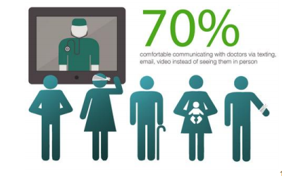

Figure 3 Cisco customer experience expectations for healthcare

In addition to improving the effectiveness and efficiency of healthcare services using telemedicine and mobile health applications, a significant amount of attention also needs to be paid to analyzing the information that is already available. Using data analytics, we can come up with specialized solutions for specific categories of patients. This will not only help in targeting the right set of patients for a treatment, but it will also help in optimizing health care services that a hospital already provides. Ultimately, a hospital can use analytics to cement its position in the healthcare industry.

## A peep into the future: implementation timeline

With increasing digitization, data is getting generated in huge volumes. Thus, it has become very difficult to manage it using traditional approaches. In 2013, we produced 4.4 zettabytes of data. This number is expected to increase tenfold by 2020.  Only Artificial Intelligence (AI) can help us keep track of the data we are producing. AI could be used to improve treatment plans, assist in repetitive tasks and tracing back medical records to their origin. IBM Watson is a significant strive forward in this regard and there are other technology giants who are trying to get into this field. The day is not far when we will be interacting with a cognitive health assistant to get successful treatments. [5].

While the first step is for the board to come to a consensus on moving forward with the proposed implementation strategy, an approximate timeline would essentially be needed before diving deeper. This is expected to vary significantly with the size and agility of the firm, along with the amount of resources that the firm is willing to allocate to the cause. A medium to large sized firm is expected need less than a year of implementation time starting from planning till the go-live phase. Though it should be noted that the initiative is not a one-time investment. While the bulk of efforts are expected to be required during the first year, a framework would need to be setup to actively monitor the operations and take corrective action as needed. Defining detailed project plans can take up to 4 months, building the framework to support the implementation 2-3 months, development effort 3-6 months, user acceptance testing 1 month, personnel training 1 month, and phased deployment 2-3 months. Note that this would have to be an agile process, and multiple tasks would be iterative and overlapping. As a result, the estimated 1-year overall timeline is expected to hold for medium to large size firms.

## Improve healthcare outcomes

Life expectancy in the United States has been constantly increasing historically. From a mere, 59.7 in the year 1930, the life expectancy value has reached an all-time high of 78.7 in the year 2010 [6]. If we take a closer look at the numbers, we will realize that each of the year’s numbers has always been better than that of the previous year since 1930. The only explanation to the above statistics could be the advancement of science, technology, and their use in medical practices over the years. The healthcare industry should watch this trend closely and consider incorporating technology in their operation in every possible way. If the implementers of the proposed solution equipped themselves technically before adopting the technology and took the security measures suggested into consideration, a comprehensive technology solution like the one suggested in this report will go a long way in improving the life expectancy number apart from reducing the cost of healthcare.

Be it mobile kiosks for dispatching medicines at places where pharmacies are not present, or the healthcare mobile app which has negated the waiting time at the hospitals, or even the telemedicine technology which enables the patients to consult the doctors from anywhere in the world, the common aspect in all the above-mentioned cases is the timeliness of administering medical assistance. This is the standout aspect of the proposed technological solution. Having access to the right intervention at the right time is an essential trait of a good medical facility. Incorporation of this technology brings us a step closer to that objective.

## References

1. “$10,345 per person: U.S. health care spending reaches new peak” Ricardo Press - <<http://www.pbs.org/newshour/rundown/new-peak-us-health-care-spending-10345-per-person/>>
2. Salka, Susan. President and CEO, AMN Healthcare “Looking ahead 2016: Workforce takes center stage in health care” - <http://www.beckershospitalreview.com/human-capital-and-risk/looking-ahead-2016-workforce-takes-center-stage-in-healthcare.html>
3. “New entrants into the healthcare market threaten traditional businesses” <http://www.healthcarefinancenews.com/news/new-entrants-healthcare-market-threaten-traditional-businesses>
4. Niedermann, Stefan. “Healthcare's digital future” - <http://www.mckinsey.com/industries/healthcare-systems-and-services/our-insights/healthcares-digital-future>
5. “Artificial Intelligence Will Redesign Healthcare” http://medicalfuturist.com/artificial-intelligence-will-redesign-healthcare/
6. “Life Expectancy at Birth by Race and Sex”, 1930–2010  
   <https://www.infoplease.com/life-expectancy-birth-race-and-sex-1930-2010>